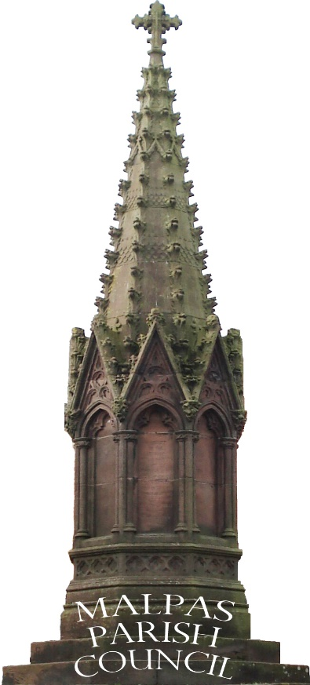

MALPAS PARISH COUNCIL GRANT SCHEME

Important Information:

Before completing your application form, please make sure you:

  - Have read the guidance notes carefully.

  - Check that your project meets the criteria and guidelines.

  - Copy your application for your own records

Answer all questions within Section A.
If you do not answer all questions your application will be deemed invalid and not processed.

The Parish Clerk will need to complete Section B.
When completed, please return your application to:

The Parish Clerk
Langdale
Sarn
Malpas
Cheshire
SY14 7LN

E-Mail: malpaspc@hotmail.com

SECTION ‘A’

Section 1 – Your Organisation

Name of Organisation
Organisations principal activities (What do you do?)

Address of your Organisation

Post Code

Is your organisation a Registered Charity  If Yes please give the charity name and number |  |  | Yes No
Section 2 – Contact Details

Title (Mr, Mrs, Miss, Ms, Other)
Contact Name

Telephone (Daytime)

Mobile Number

Email Address (This will be used for any correspondence)

Section 3 - Your Project / Activity
Project Title:
Project Timescale: |  | Start date: |  |  | End date:
Project Description:
Please provide a short overview of your project.
What is the aim of the project and why do you need the funding?

Where will the project take place?

Are you working with others? If yes, who are they?
What age group will benefit from the project? | 0-19 20-64 65+ All ages
Project Outcomes:
Please provide a short overview of what your project will achieve. Include information such as:
Why is the project needed?
How many people will benefit?
How will the local community benefit?
How does your project meet the Malpas Parish Council annual objectives and priorities
Section 4 - VAT
Are you registered for VAT? |  | Yes / No
Are you able to claim back your VAT? |  | Yes / No
Section 5 - Project / Activity Costs
What will the money be spent on? For those items where you are not able to reclaim any VAT payable please state the value in the VAT Column:
Please list the cost of each item included in your TOTAL project cost |  | Net Price (£) |  | VAT (£) |  |  | Total (Net + VAT) £
Total Project Cost Including Non-recoverable VAT (A)
Section 6- Proposed Project Funding

Please detail below all sources of funding that will contribute towards total project cost: |  |  |  |  |  |  | £
Organisations own resources
Grants from Other Sources
Other
Total Funding (B)
Total Funding Requested from Parish Council Budgets (A-B) :
Section 7- Parish Council Grant Request (s)

 |  |  |  |  |  |  | Amount (£)
Total of Grant Requested (This must match Total Funding Request shown in Section 6)
Section 8 – Bank Details

Please provide details of your organisation’s bank
Name of your organisation as it appears on your Bank Account:
Section 9 – Applicants Declaration

Please provide the names of 2 Authorised Members of your Organisation in whose name this application is made.
Full Name |  | Position in Organisation |  |  |  | Date
Section 10 – Terms and Conditions
Please tick the box below to confirm that you have read and agree to Malpas Parish Council’s standard conditions of the grant scheme which are shown on the Council’s website. These include acknowledging the Council’s support when producing any promotional material or publicity and the provision of monitoring information when requested. This will include the completion of a monitoring form and the provision of receipts or other details of any expenditure.

Section B

PARISH COUNCIL APPROVAL FORM

This form should be used by the Parish Council to confirm the amount of funding awarded from their budget or to inform the applicant why the application has been refused.

Project Title:

Application Approved |  |  | Application Rejected

Amount of grant requested

Amount of grant awarded

Conditions as applied to grant
You will be expected to attend the next Malpas Annual Parish meeting (held in May) to report on the progress of your project or activity which has been given the grant.
Grant recipients may also be expected to provide evidence of expenditure, e.g. receipts, etc.

Reasons for refused:

The application has been refused because:

Signed on behalf of Malpas Parish Council:

Name | Date

