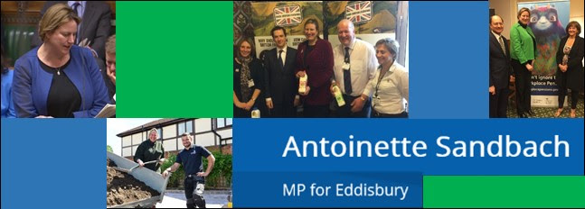

Since the last Newsletter, Antoinette has...

- Met with Ben Gummer MP, from the Department of Health to discuss child loss
- Opened the new tractor for the Tilston Playing Field Association
- Met with North West business leaders over lunch
- Visited the village of Eaton to meet with Mrs Kelly to discuss future site of Dray’s coffee shop
- Discussed the future of Cheshire and the UK on Sunday Politics North West
- Met with Dr Nikki March in Westminster to discuss Cancer Research UK
- Responded to the review of petitioning procedures on hybrid bills
- Spoke in the Estimates Day Debate on Energy and Climate Change
- Discussed the future of the dairy industry at the Dairy UK annual dinner
- Attended Energy and Climate Change select committee meetings
- Supported ‘Singing for Syrians’ in Parliament
- Attended the Cheshire Business Leaders garden party in Oulton
- Dropped into the Women in Politics and Media reception

Meeting with Ben Gummer MP

Following up on the work on hospital bereavement services I have been doing, I met with Ben Gummer MP, Parliamentary Under Secretary of State for Health Services at the Department of Health. The meeting was extremely productive and we discussed an array of options for the improvement of maternity bereavement services within the NHS such as looking at the role of the bereavement midwife and introducing bereavement facilities to every trust.

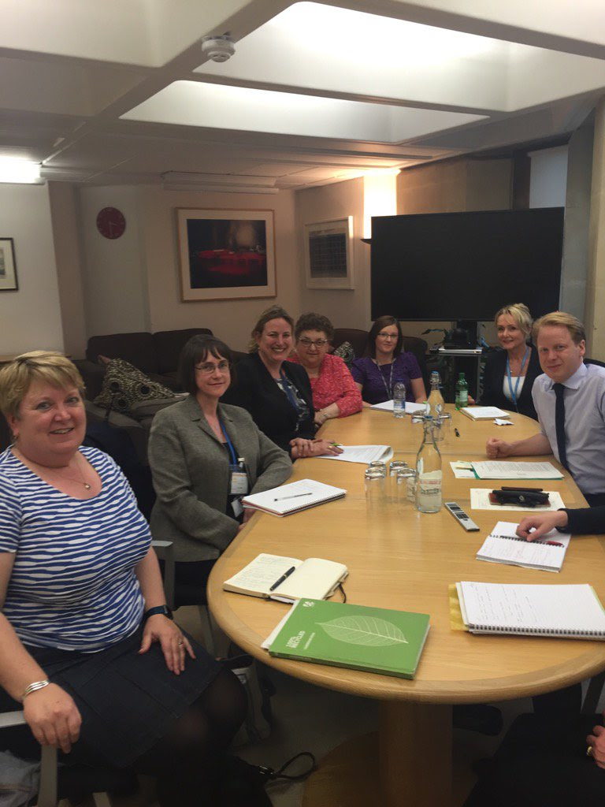
Chilcot Report

Sir John Chilcot has published his report into his findings on the UK's involvement in the 2003 Iraq War. The report clearly shows that Tony Blair actively ignored the advice of his cabinet and the UN in the lead up to the invasion. It is clear from the report's findings that the Iraq War was an ill-conceived act of military aggression that cost 179 British servicemen and women their lives. I believe that it is essential that Mr Blair and those in the Labour cabinet at the time are held accountable for their actions. The Prime Minister recently outlined the lessons that must be learnt from the invasion but cautioned that it is wrong to conclude that intervention is always wrong. I feel that it is imperative that we learn the lessons from the Iraq war and work towards building a safer world.

North West Business Lunch

Last week, I attended a business briefing for North West MPs hosted by the North West Business Leadership Team. The briefing was extremely productive and I met several business leaders from Cheshire and the North West. I sought to address concerns over the future of business and industry in the region and discussed how business may change as a result of Britain’s exit from the EU.

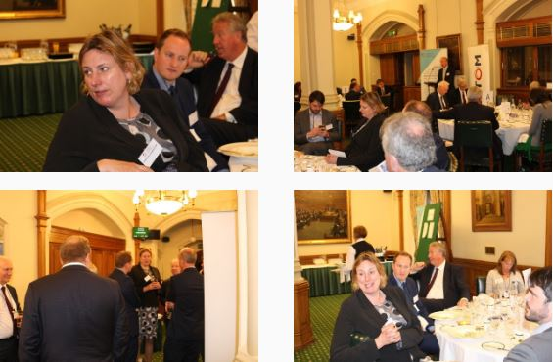

Cancer Research UK

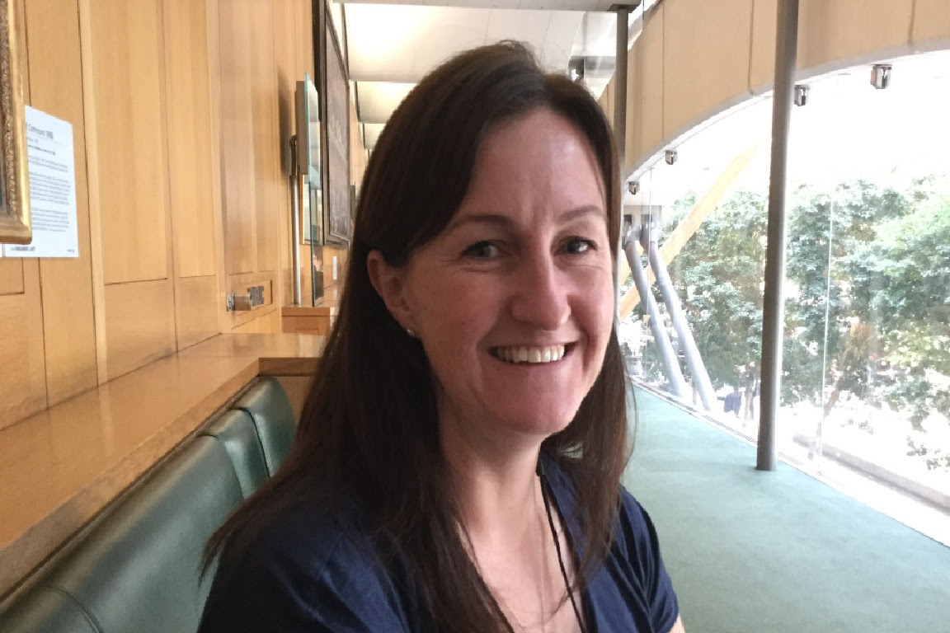
On Tuesday Dr Nikki March came to Parliament as the Eddisbury campaigns ambassador for Cancer Research UK. Over 100 campaign ambassadors came to parliament to meet with their MPs on Cancer Research UK’s Parliament Day. Dr March attended a variety of events around the Parliamentary estate and we had a very productive discussion around what we can do in Eddisbury to help eliminate cancer.

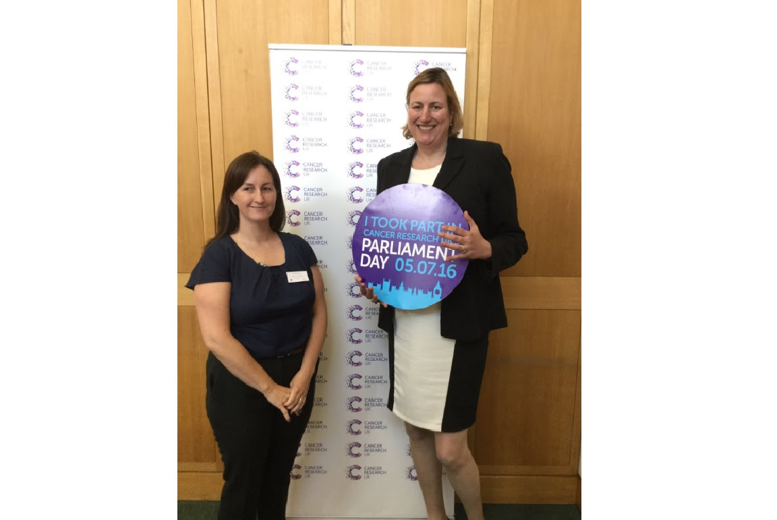

Sunday Politics North West

I was invited to speak on Sunday Politics North West with fellow parliamentarian Angela Rayner, Shadow Secretary of State for Education. We discussed and debated a number of issues with Arif Ansari, including the Conservative leadership contest and the current crisis enveloping the Labour party.

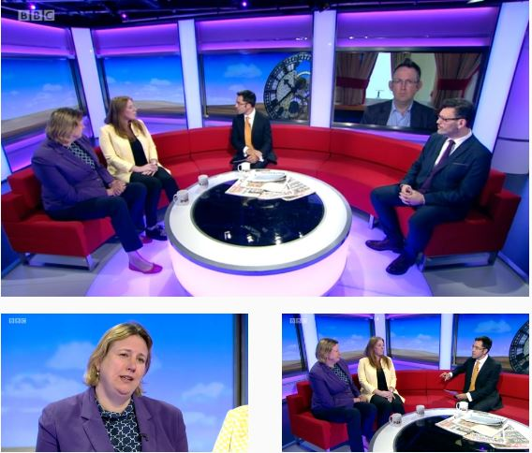
Tilston Playing Field Association

I was delighted to open the new tractor at the Tilston Playing Field Association. Children and adults alike were very pleased with the new addition to the play area and I was extremely impressed with the all facilities available to members of the public.

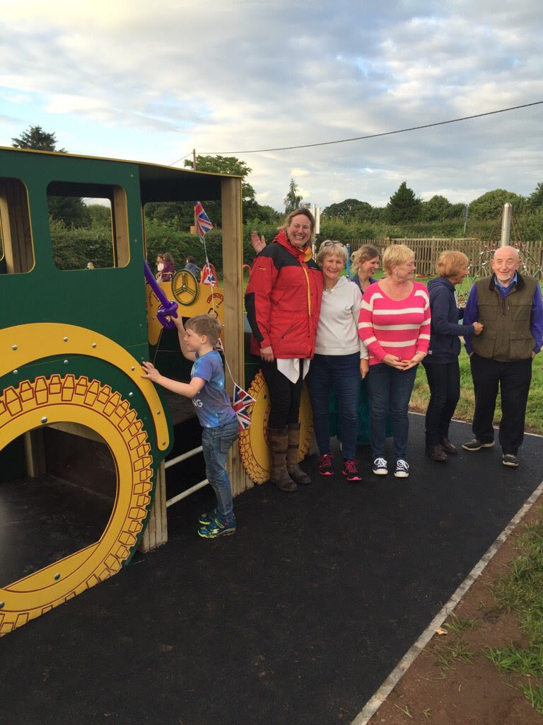

Singing for Syrians

I attended a drop-in event in Parliament for ‘Singing for Syrians’. This nationwide initiative supports people injured or displaced by the war in Syria. The money being raised goes to paying the salaries of the Syrian medical team operating in Aleppo and it is hoped that the scheme will be rolled out across the country.

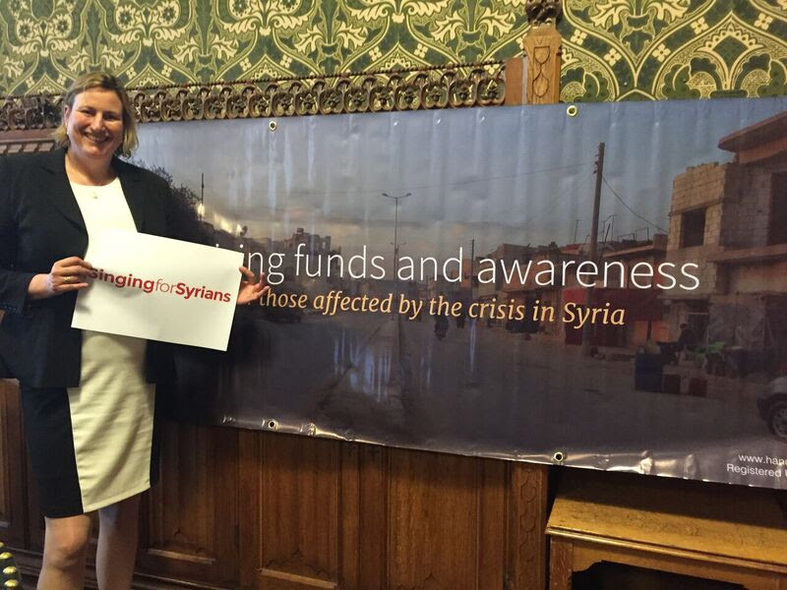

Smart Energy GB

I also went to an event raising awareness of smart meters, hosted by Smart Energy GB. Smart meters will bring everyone in Eddisbury and the rest of Great Britain accurate bills at no additional cost. The amount of gas and electricity that’s been used will, for the first time, be shown in pounds and pence and in near real time. With this information consumers will know exactly how much the next bill will be, and can make informed choices about their energy use.

