Time: 3 to 3.5 Hours
Mileage: Approximately 8 miles
Registration: 09:30 am – 10:00 am
Start: 10:00 am
Start at Bickerton Village Hall opposite Reading Room Lane
At the entrance gate facing Reading Room Lane, turn left towards Holy Trinity (Bickerton) Church.
At the next cross roads turn right into Goldford Lane.
Just beyond Bickerton Church turn right onto the Sandstone Trail. (Footpath Bickerton FP 10)
Follow the Sandstone Trail footpath to Shay Lane

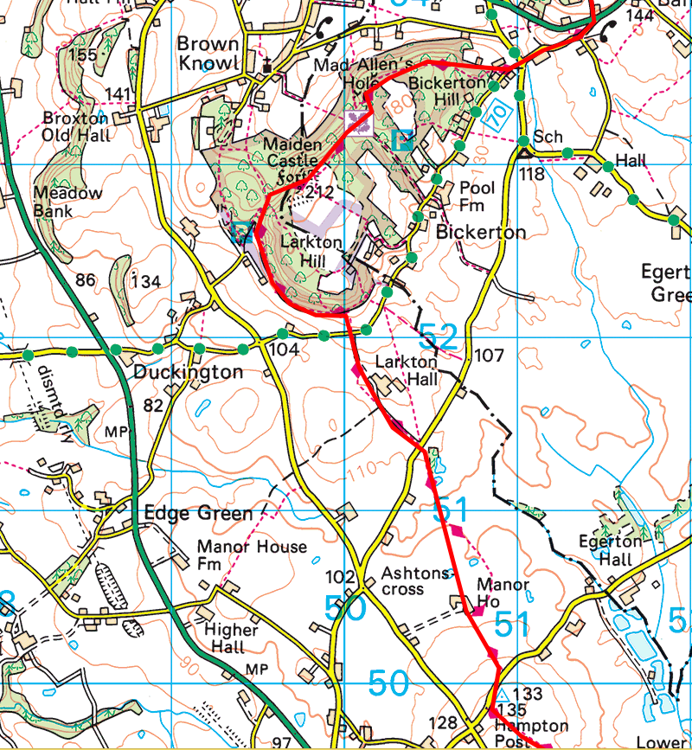
Detail:
Bickerton FP 10
Beyond Mad Allen’s Hole at the broken wooden fingerpost turn right
Bickerton FP32 – Rest halt overlooking Brown Knowl Village. Dee estuary in the distance.
At Maidens Castle turn right and descend the hill.
At wooden Finger Post turn left on to Duckington FP11, (signposted Hampton and Whitchurch)
Duckington FP1, Duckington FP14,
At Sandstone Trail Information Board turn left.
Duckington FP8, Duckington FP3 Larkton FP9 Larkton FP8
Cross Goldford Lane (Water and waste station 1.)
Caution Electric Fences and Livestock hazard. – Dogs on leads.
Group consolidation before walking through Larkton Hall land
Larkton FP3 to Long Lane. Livestock and mud hazard. – Dogs on leads.

Cross Long Lane onto Larkton FP2 – Caution Electric Fence. Livestock – Dogs on leads.
Cross Concrete Sleeper road - No signage.
2 styles and bridge over brook onto Hampton FP6 - Racehorse Training ground – Dogs on Leads
Turn left onto Hampton FP7 alongside Stables Driveway to Shay Lane
Approximately 5.0 Miles / 2 Hours to this point. (Water and waste station 2.)

At Shay Lane turn right to the water and waste station
(Walkers will have a few minutes rest in order to consolidate the group.)

Continue down Shay Lane towards Hampton and the A41 Trunk Road.
Straight across Hampton Post cross roads in to Cholmondeley Road.
Follow Cholmondeley Road down to crossroads on A41 Trunk Road.
Straight over the A41 Road (Extreme Caution) then take a left over style onto footpath Hampton FP1 just beyond the Yesteryear Rally field security fencing.
(Note chair by side of style is movable to allow dogs to get through fencing.)

Follow Hampton FP1 onto and along old Whitchurch – Chester Railway line.
Continue through two gates, then turn right onto farm track (footpath Malpas FP23) just before steel barn
Continue on Farm track to Ebnal Lane (Gate / Style) Straight over Ebnal Lane over style onto footpath Malpas FP17.
Keep left of two ponds then right over style on to footpath Malpas FP19. Continue past Badger sets. (Caution holes) to next hedge line.
Turn left Greenway Lane (9.0 miles)
Turn left onto footpath Malpas FP17 and follow over style by Observer Post onto Greenway Lane.
Turn left and follow Greenway Lane to Well Meadow.
Turn right into Well Street.
Up Well Street to Malpas Cross, then up Church Street to St Oswald’s Church
(Approximately 7 Miles – 3 Hours)

