Malpas Gems Submission 1

1/ The Victoria Jubilee Hall
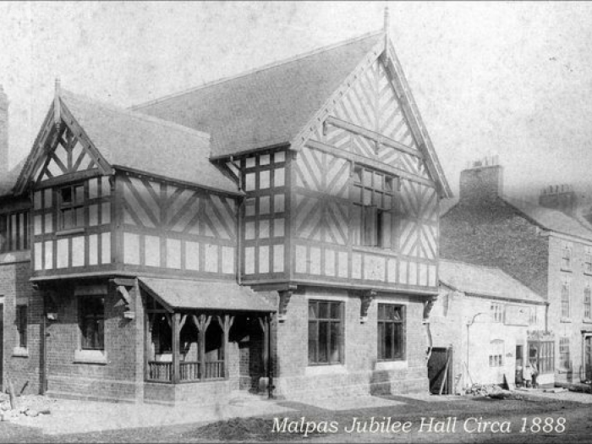.

David Hayns Book – The Jubilee Hall 1887 – 1987
Malpas Online - THE JUBILEE HALL (malpascheshire.org)

A public meeting was held on February 5th, 1887, in the Malpas Infant School to discuss ways in which Queen Victoria’s Golden Jubilee could be celebrated.

At a subsequent meeting, the Marquiss of Cholmondeley offered to give the site for the building on High Street, and a committee was appointed to raise the estimated cost of £900.
The Malpas Victoria Jubilee Hall was eventually opened by the Marquiss on 7th August 1888.

2/ Malpas during the Civil War
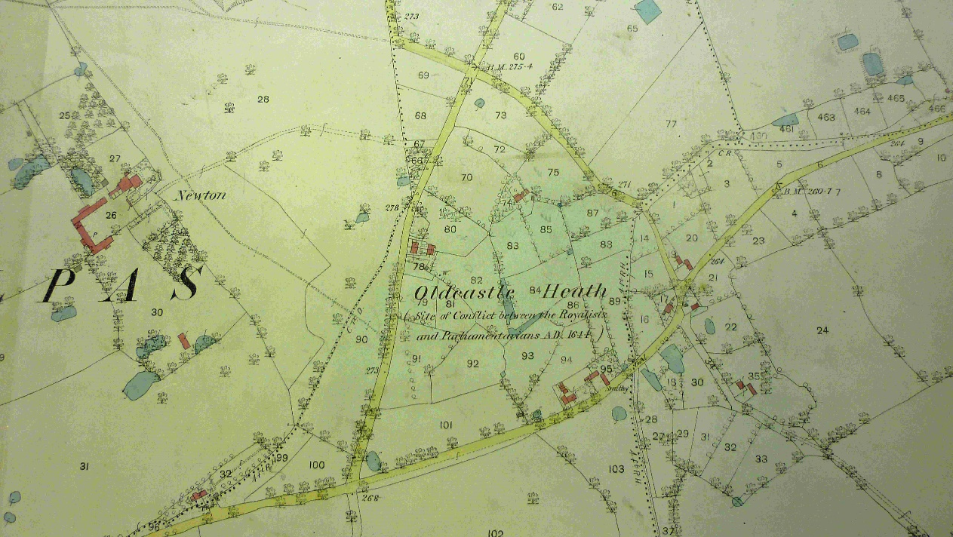
David Hayns Book - Alport, Cholmondeley and Dod for the King
Malpas Online - Alport, Cholmondeley and Dod for the King (malpascheshire.org)

An account of the way in which the Civil Wars of the 17th century affected Malpas and the surrounding area.
This book describes key events such as:
- the use of Saint Oswald's church as a dormitory for Parliamentarian troops from Nantwich
- the plunder by them of the saltworks in Wigland
- the assault on Cholmondeley House
- the hangings at Gallantry Bank, Bickerton
- the Battle of Oldcastle in 1644.

3/ Malpas and the Great War
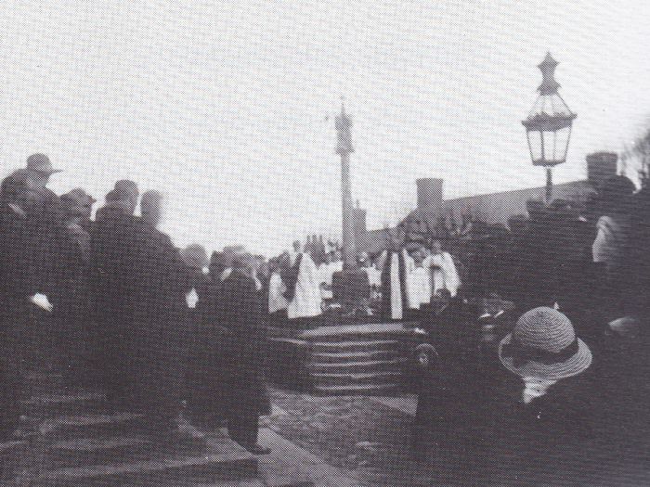
David Hayns Book – Malpas and the Great War 1914 -1918

Malpas Online - MALPAS AND THE GREAT WAR (malpascheshire.org)

The book tells of the way in which Malpas reacted to the outbreak of war in August 1914, and covers:
- the establishment of a voluntary Red Cross hospital
- the welcome extended to two families of Belgian refugees
- local recruiting for the armed forces and wartime farming
- social life both during and immediately after the war
- the devastation caused by the Spanish influenza epidemic
- the gradual return home of local servicemen
- the dedication of the Malpas war memorial in the churchyard, in 1920.

4/ Richard Alport's Charity Children (i5- c 10748)
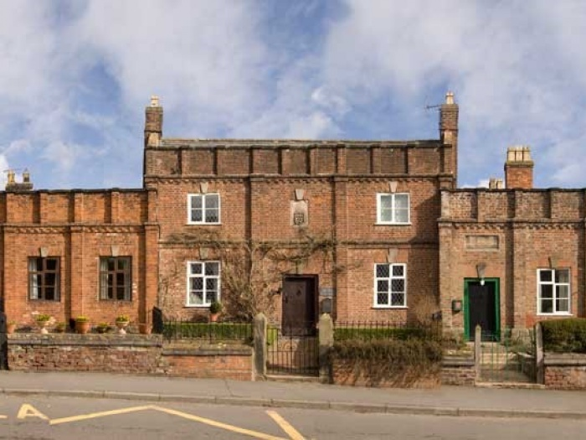
David Hayns Book – Richard Alport's Charity Children

Malpas Online - RICHARD ALPORT'S CHARITY CHILDREN (malpascheshire.org)

Early years education at Malpas Alport Primary school has been carried out in several buildings.
Formal education started back in 1745 when a fund set up by Richard Alport of Overton provided the original building on High Street.
Extensions were added in 1815, and 1833, but all three building are now private residences.

These were followed in 1874 by the building of a second infants’ school and 1889 saw the large Joseph Lewis Building opened in its present location on Chester Road.
A headmaster’s schoolhouse was added in 1895. (Now demolished)

5/ Malpas and the Home Front
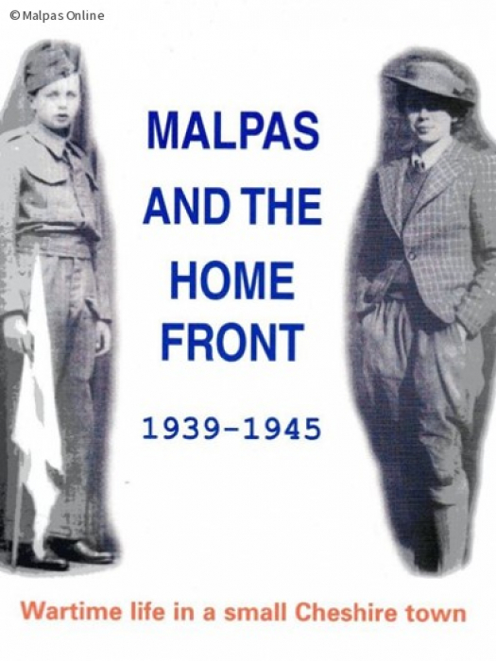
David Hayns Book – Malpas and the Home Front

Malpas Online - Malpas and the Home Front (malpascheshire.org)
Based on interviews with individuals who lived in Malpas the book covers:
- the effects of the reception and housing of evacuees from Liverpool and London
- wartime farming, including contributions by Women's Land Army and prisoners-of-war
- local fund-raising such as 'Spitfire' and 'Salute the Soldier' weeks
- the Home Guard; Czechs, Poles and Americans on the streets of the town
- the return home of service women and men after the war.
- Details of the nineteen men commemorated on the Malpas war memorial.

6/ Malpas: Cheshire's Town in the Marches
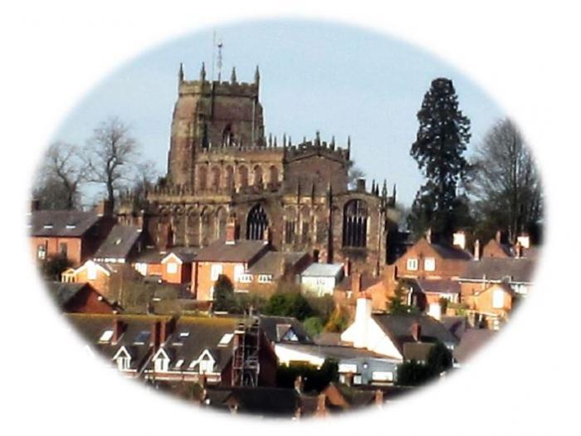
David Hayns Book – Malpas Cheshire’s Town in the Marches

Malpas Online - Malpas: Cheshire's Town in the Marches (malpascheshire.org)

A concise and well-illustrated general history of Malpas, written for both residents and visitors

It covers:
- When the Roman road, now Malpas High Street, came down from Hadrian's Wall, through Chester and Whitchurch and on to Kent.
- the Norman invasion of 1066 and the establishment of Malpas as a medieval borough and market town
- the intervening centuries until 2016, when Malpas started to undergo a period of unprecedented housing development.

7/ Malpas, Parish, Town and Church

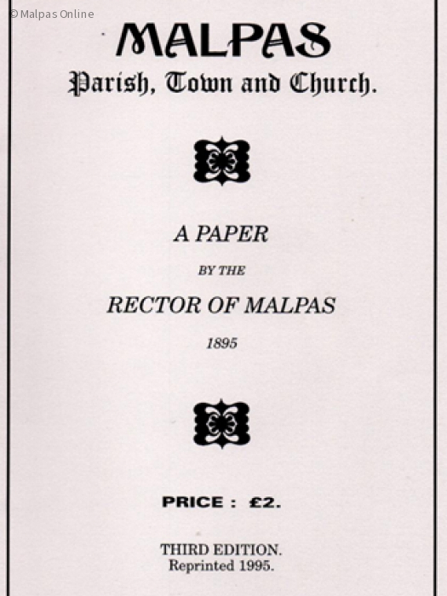
Paper by the Rector Rev. William Kenyon – Malpas Parish, Town and Church.

Malpas Online - Malpas, Parish, Town and Church (malpascheshire.org)

A 1895 description of the Town, the whole Parish and the secular and ecclesiastical local history by the Reverend William Kenyon (Rector of Malpas). The original paper first published in the Chester Archaeological and Historic Society’s Journal, new series volume III of 1890, draws extensively on many historic documents

8/ More Old Fashioned than Most

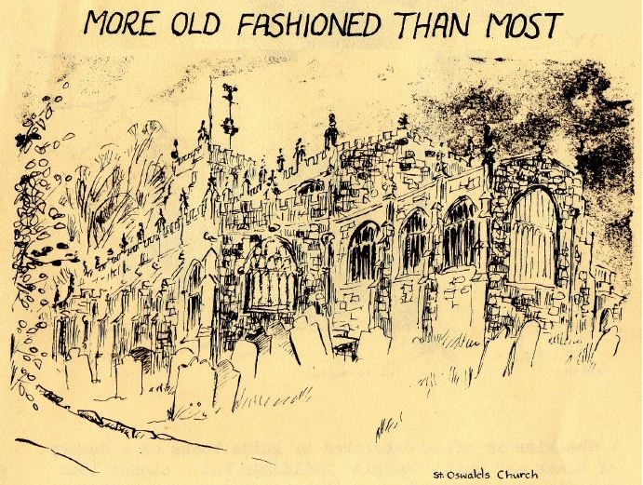

David Hayns Book – More Old Fashioned than Most

Malpas Online - More Old Fashioned than Most (malpascheshire.org)

Cheshire is often described by guidebooks as a county of black and white “magpie” buildings, but a closer look reveals that the number of these timber framed buildings surviving, whilst distinctive is comparatively small.

This short guide looking at Buildings in Malpas (1980) will prove that it is certainly not slender in antiquarian interest!

"The town has remained old fashioned for longer than most though today apart from the Church, its antiquarian interests are of the slenderest." (Fred Crossley – "Malpas Church" 1936)

9/ Poet and Parish Priest
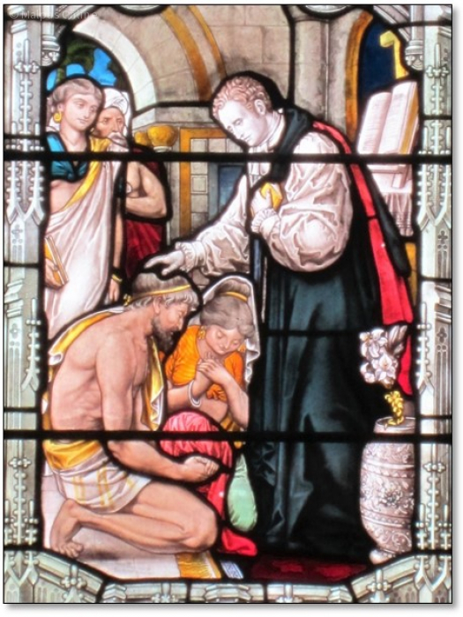.
David Hayns Book – Poet and Parish Priest

Malpas Online - Poet and Parish Priest (malpascheshire.org)
An account of Reginald Heber's (Bishop of Calcutta) life in Malpas and Hodnet.

On 21st April 1783 his father wrote to his sister in London
“I take the very first opportunity of acquainting my dear friends that my dear Mary was, a little after three this morning, safely delivered of a fine lad. I thank God she and the little Bab are both as well as can be expected. He is as fat as a little mole, and they say looks very well.”

Picture is of the stained-glass window in St Oswald’s Church

10/ Brereton Chapel
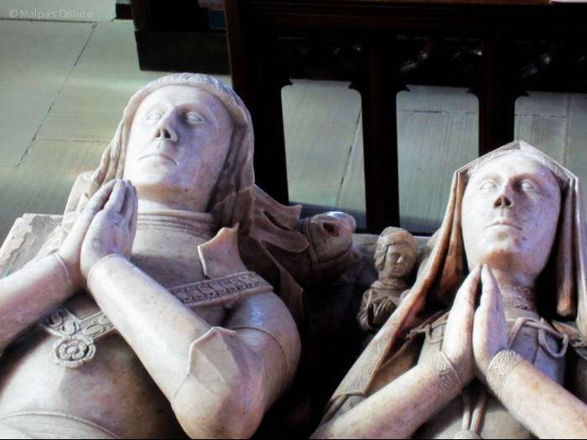..

In Search of my Ancestors - A Collection of Brereton Family Histories by Faye Brereton-Goodwin

Breretons of Malpas – Brereton Family History (breretonhistory.ca)

The history of the Malpas Breretons, begins with Randolphus de Brereton (born in the 12 century) who married Cecile St. George and continued through the generations to the 19th century including the Welsh family of Borasham, the Cheshire Breretons, and the Malpas Breretons.

A tomb dedicated to Sir Randolf Brereton and his wife Lady Eleanor is situated in Brereton’s Chapel in St Oswald’s Church at Malpas.

11/ Item vacant

12/ Breretons of Malpas Pedigree Role
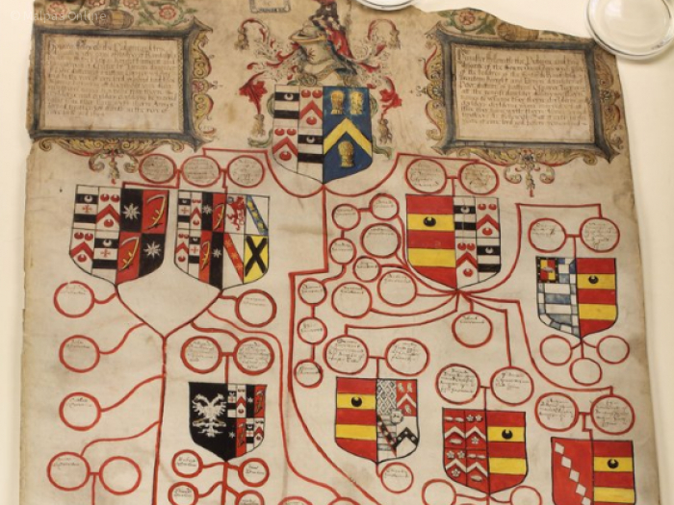
William Brereton, beheaded, accused of adultery with Anne Boleyn (papers in Crown Archives)
https://www.hslc.org.uk/wp-content/uploads/2017/05/123-2-Ives.pdf

During the reign of King Henry VIII, William Brereton was lord of the manor of Malpas.
He was a powerful man in Cheshire, which at that time was governed as a separate entity from the rest of England.

It is recorded that he could ride from Malpas to Chester on his own land.

A power struggle was taking place around King Henry between factions that supported Henry’s second wife Ann Boleyn and those that supported his third wife Jane Seymour

On 10th May 1536 William was arrested along with six other high-ranking individuals close to King Henry.

Subsequently William died under the executioner's axe on 17th May 1536 for the high treason of adultery with Anne Boleyn.

All his property, including his papers, became the possession of the Crown.

His successors are the Cholmondeley’s who still own Cholmondeley Castle and land in Norfolk

13/ Castle Hill Motte
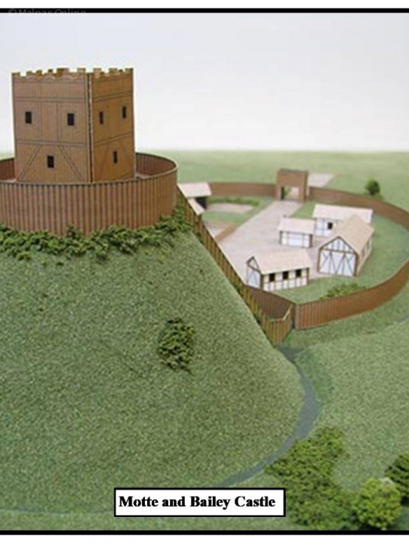
Malpas Online | Castle Hill Motte - Recent History (malpascheshire.org)

Malpas Castle was built, probably in the early 12th Century, for the Barons of Malpas.
It was part of a series of defences along the Welsh border and was linked with Aldford, Oldcastle and Shocklach castles.

The motte survives to 3.7 metres (12 ft) in height and is 37 m (40 yd) in diameter and is surrounded by a ditch.

Over the more recent centuries, the Motte has been used for a number of purposes, including celebration dances, a meeting place for the Malpas Friendly societies,
a ladies bowling green, and the Town Reservoir.

14/ Friendly Societies
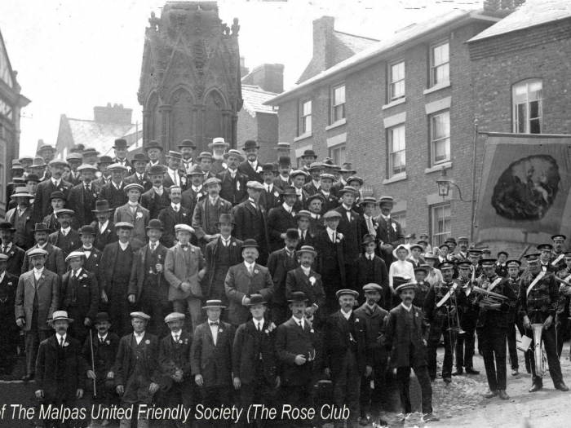.
Malpas Online - Malpas Friendly Society (malpascheshire.org)

A friendly society is composed of a body of people who join for a common financial or social purpose. e.g. for the purposes of insurance, pensions, savings or cooperative banking.

At the turn of the 20th century Malpas had two Friendly Societies one being the Rose Club (founded in 1824) and the other being The Oddfellows, which is still an active organisation today.

Both held an annual feasts which consisted of a parade through the Town led by Malpas Town Band.

The parade usually went to the Castle Hill where the feast was held followed by dancing.

15/Cholmondeley Castle Malpas
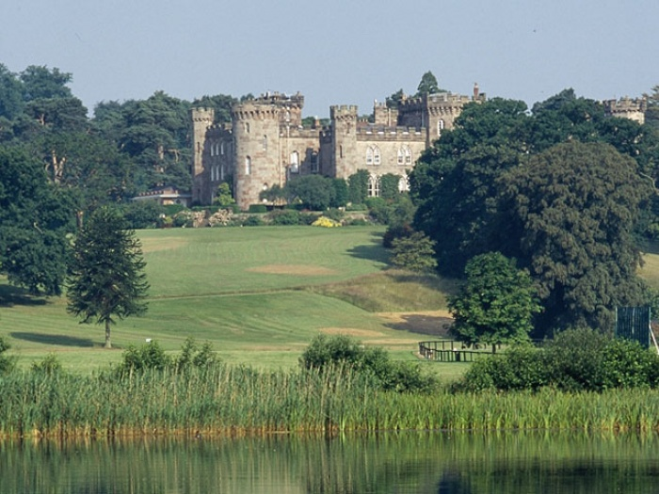.
Situated in South Cheshire, Cholmondeley Castle is a Grade II listed country house in the form of a crenelated castle with formal gardens and surrounded by parkland.

It has been a seat of the Cholmondeley family since the 12th century.

The present form designed by George Cholmondeley, 1st Marquess of Cholmondeley and extended to designs by Robert Smirke dates from the start of the 19th century.

The Gardens and grounds only, are open to the public; the Castle being a private residence.

Opening times 10am-5pm (last entry 4pm)
Monday Bank Holidays
Wednesday, Thursday and Sunday

Closed Tuesday Friday & Saturday

16/ Local Rural Races
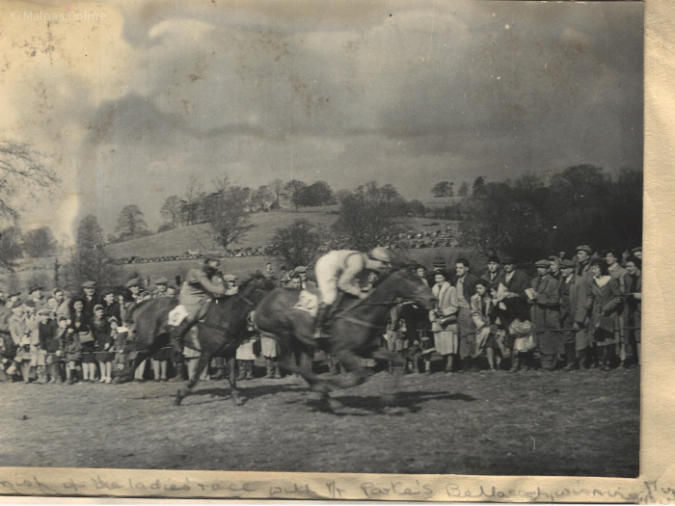
Malpas Online | Local Rural Races (malpascheshire.org)

Overton Heath
Until around 60 years ago point-to-point steeplechases were still hosted by the Barnett family at Overton Hall, just outside Malpas.
They were organised by the Wynnstay Hunt, and presided over by the joint Master Sir Watkin Wynn, whose photo appears in a Cheshire Life article about the event, published in May 1962.

17/ Malpas Cemetery
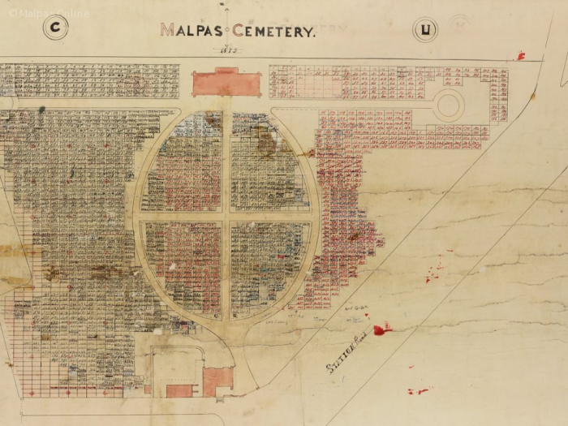.
Malpas Online Malpas Cemetery - A brief History (malpascheshire.org)

Malpas Cemetery dates back to 1873 when the St Oswald's Churchyard was almost full.
2 ½ acres was purchased from the Marques of Cholmondeley for £250 and the Malpas Joint Burial Board formed to represent the parishes of Bickley, Bradley, Hampton, Macfen, Malpas, Overton, Tushingham, Wigland and Wychough.

The committee borrowed just over £1,500 to pay for the land and building the lodge and the chapel of rest from the Government’s "Public Works and Commerce Fund".

18/ Malpas Fairs
Picture / item relating to the Edward I - Fairs & Markets

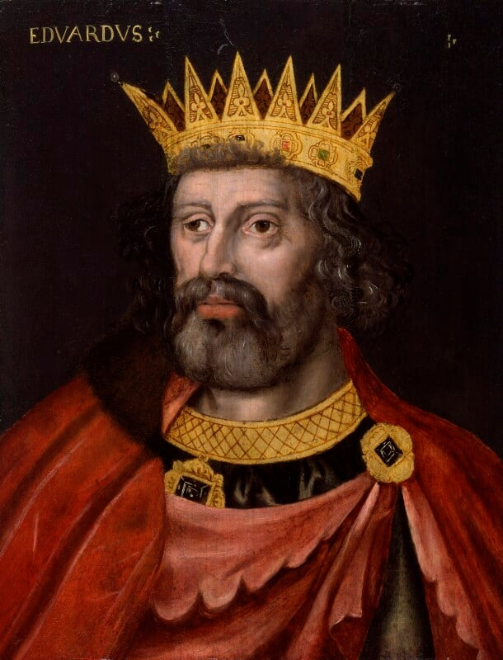
Malpas Online - Malpas Fairs (malpascheshire.org)
In 1281 King Edward I granted a charter to "Philip Burnel and to Isabel, his wife that they and their heirs shall have for ever a weekly market on Mondays at their manor of Maupus... and a fair in the same place to last for three days each year."

The fairs, mainly for buying and selling of livestock, lasted until the late 1800s, although the weekly markets ceased to operate around the middle of the 19th Century.

19/ Malpas Wesleyan Chapel
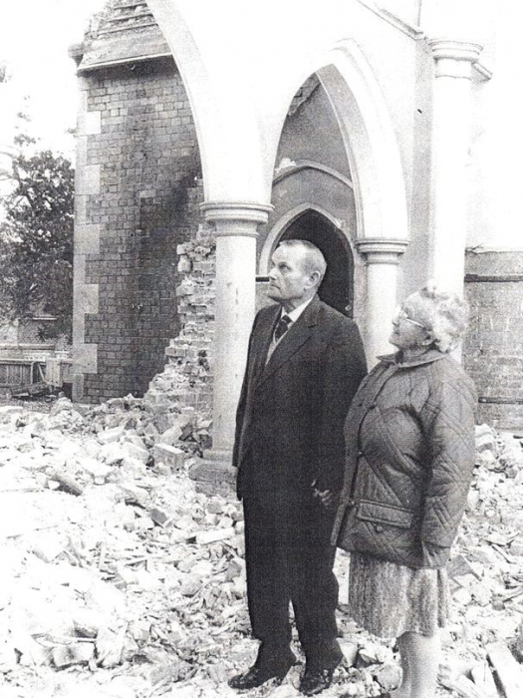.
George and Nessy Worth standing on the spot where they were married 60 years previously amid the last remnants of the former Wesleyan Methodist Chapel,
that originally opened in 1875. It eventually closed for worship in 1969 and was demolished in1985.

Pictured are.

Four terraced homes and a block of garages know as Chapel Rise now exist on the site.

The garages are a conversion of the original stables, built for the horses of visiting preachers and worshippers travelling from a distance.

1935-1968: register of marriages

20/ Malpas Water Supply
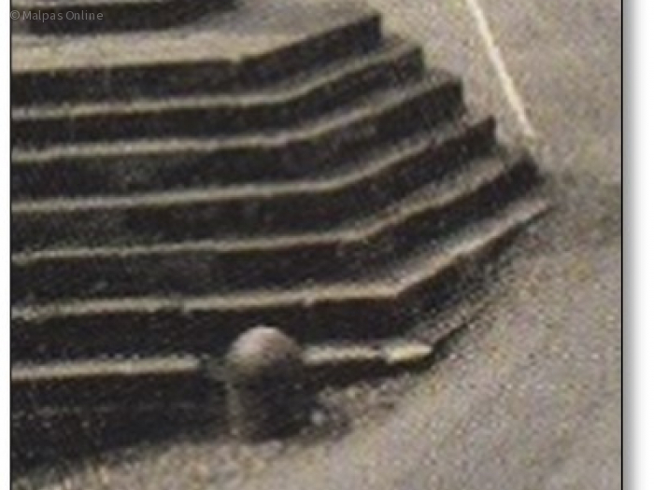

Malpas Online | Malpas Water Supply (malpascheshire.org)

Sitting on top of a hill, Malpas was not best placed for a water supply. But there were several wells and by the 18th century some of them had been fitted with hand pumps.

In 1737 Thomas Parbutt was paid two shillings (10p) by the Malpas Highway Surveyor 'for cleansing the well' and in 1765 Joseph Vaughan was paid half a crown (12.5p) 'for mending ye town pump, which was situated in Well Meadow

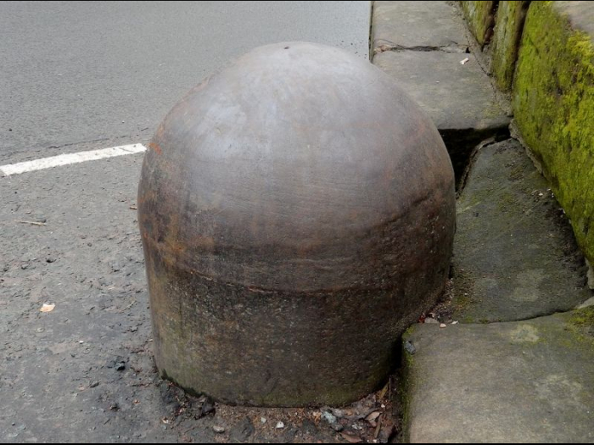.
The steel dome by the cross was part of the town water supply and containing a valve on the line of the piped water to the reservoir situated under Castle Hill

21/ Malpas Alms Houses
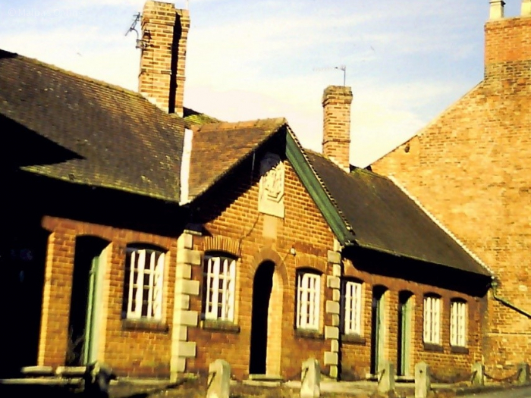

Malpas Online - FIVE HUNDRED YEARS OF AFFORDABLE AND SOCIAL HOUSING IN MALPAS (malpascheshire.org)

Sir Randle Brereton, who died in 1530, founded alms houses, originally for poor elderly men.
They were replaced, and possibly moved to the present site now known as Cholmondeley Terrace, in Church Street.
Although the alms houses were rent free, the almsmen did have to say prayers daily for the souls of Sir Randle and other deceased members of the Brereton family.

These prayers were intended to lift the souls of the deceased out of the limbo state known as 'purgatory', into the higher realms above.

1857-2017: records incl minutes

Poor Houses, Poor Law
- Wrexham (1837-53)
- Whitchurch (1853-1930)

22/ Climate Change
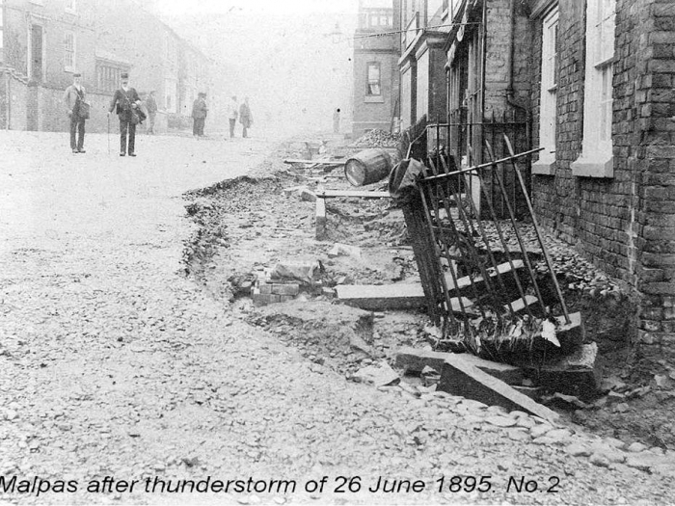

Storms associated with Climate Change are perhaps nothing new.

On 26th June 1895, there was a tremendous thunderstorm which washed away the pavements in the High Street.

It may have been that this particular storm was also responsible for road surface on Church Street also being washed away, and during subsequent repairs the road level was raised, (Sunken pavement exists) and a set of steps were installed alongside the Cross.

23/ Malpas Fire Service
Approach Mark Spennati for detail

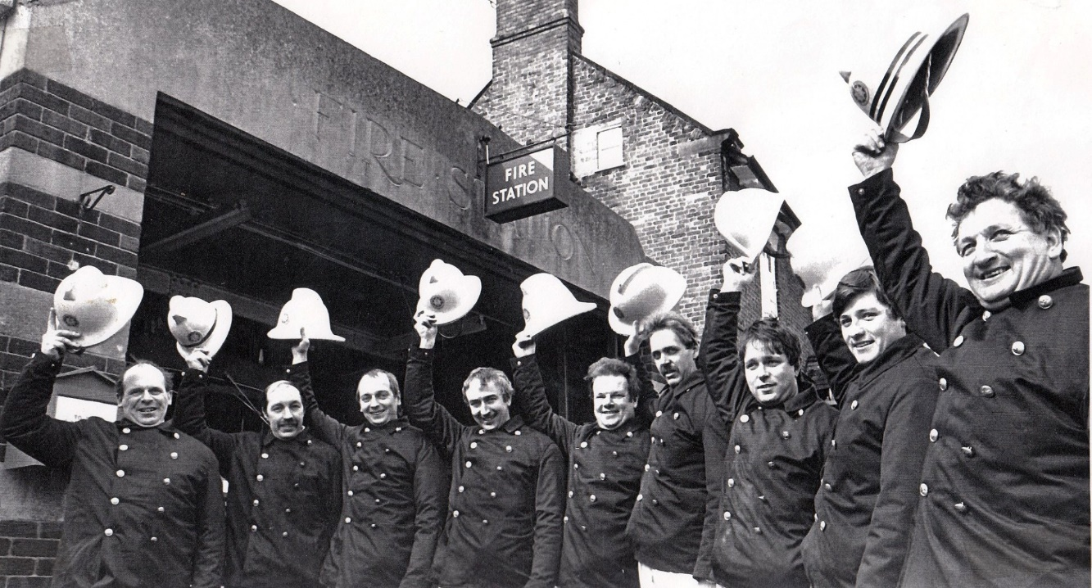

Pictured from left to right
Geoff Hodgkinson, Ian Scofield, Ray Crump, Ronnie Bradley, Derek Roberts, Terry Rich, Mark Spennati, George Roberts Junior, George Roberts Senior

Malpas Fire Brigade members pictured outside the 1934 building on High Street.

In 1936 Tarvin RDC had taken over control of the Malpas Fire Brigade from the former Malpas RDC.

the Fire Services (Emergency Provisions) Act of 1941 brought all fire brigades into the new National Fire Service.

This continued to be the case until 1947 when the National Fire Service was dissolved, and Malpas Fire Brigade was incorporated into the new Cheshire County Council Fire Brigade.

24/ The Gas Works

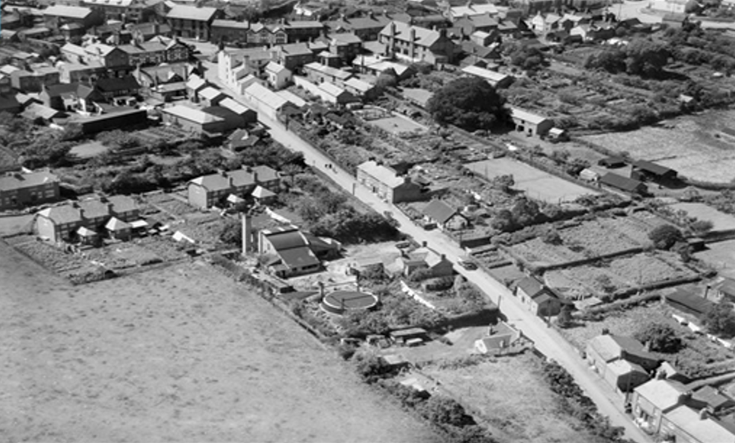
.

1947 Aerial photography of Malpas showing the gas works off Well Street.

The buildings in the centre of the picture contained the coal burning retorts and produced the coke and gas tar which was then sold on to the public.

In addition, the spent coal known as coke was sold to residents to supplement their coal stocks.

25/ Belgium Refugees
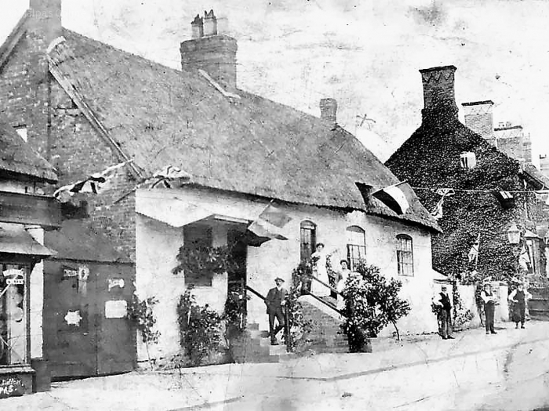.

Belgium flags on High Street welcome refugees.

Following Germany’s invasion of Belgium in August 1914 around 100,000 Belgians fled to Britain, of which 600 to 700 came to Cheshire.
A hastily formed Malpas committee agreed to house two Belgian families and Mr Greenshields offered the use of ‘Hilbre’ a bungalow on Tilston Road, as accommodation for one of them.
The head of that family was William Grunfeld.

The other Belgian family was offered accommodation in one of the Malpas Rural District Council properties at Sunnyside.

26/ King George V's Coronation Day (i9 - c 10722)
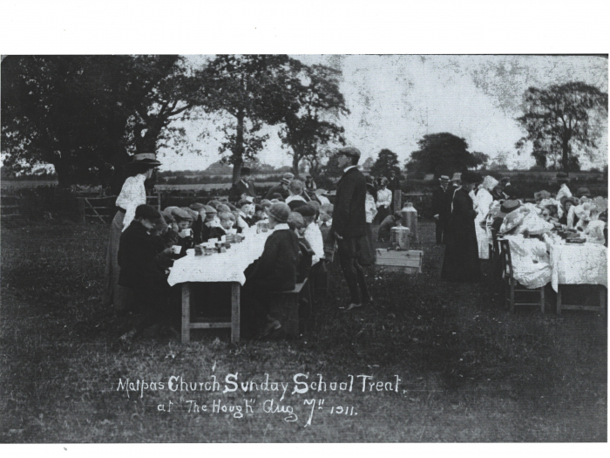.

27/ Past Public Houses
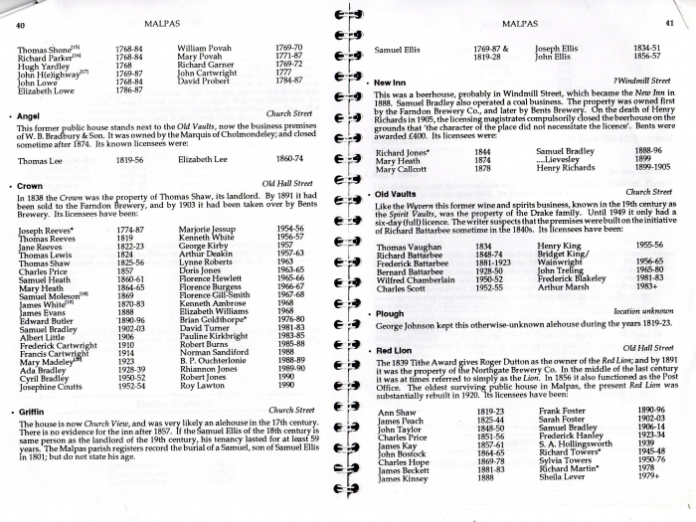.
Malpas Online | Past Public Houses in Malpas (malpascheshire.org)

Extract from a list of Public Houses and Inns in Malpas published in 1992

28/ The Cross
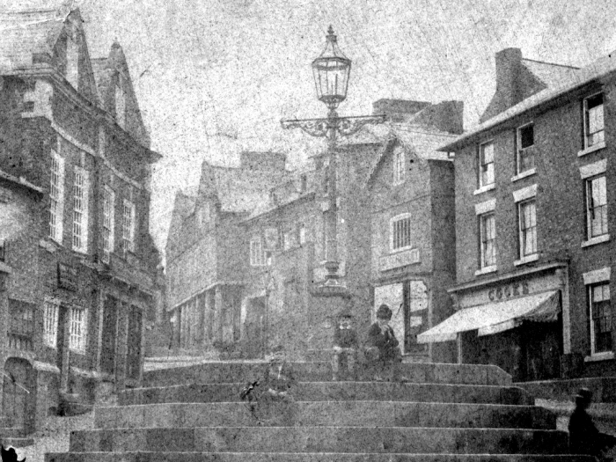.

Malpas Online - The Cross (malpascheshire.org)

Did you know that once upon a time the road ran either side of the Cross?

In antiquity, the area around the Cross was where the Malpas village fairs and markets were held.
An early picture looking up Church Street gives a view of an earlier Cross.

29/ Development on Old Hall Street

An extract from the 1836 – 1841 Tithe Maps illustrates that Old Hall Street was the site of seven paupers’ cottages, built around 1789, which in 1851 seem to have accommodated eleven families ranging in size from one to eight persons.

One of the cottages was also a lodging house accommodating a family of three plus five lodgers.

The cottages were demolished at some time between 1869 and 1874, and a smithy was built on the site by Alfred Furber. (See also Malpas Gem number 32.)

30/ Houses for the poor of Malpas Township

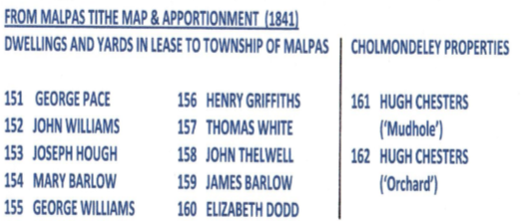

Extract from Malpas Parish Magazine March 1869
“It appears that eleven cottages and three plots of land on Old Hall Street, were leased to the township of Malpas, in the year 1789, for three lives, the last survivor being Mr Gardener, who emigrated to America, and died there three years ago…

When the lease was granted, there were no workhouses, and these properties was leased to provided houses for the poor of the township.”

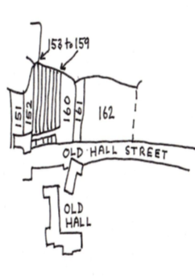

31/ Sanitation on Old Hall Street

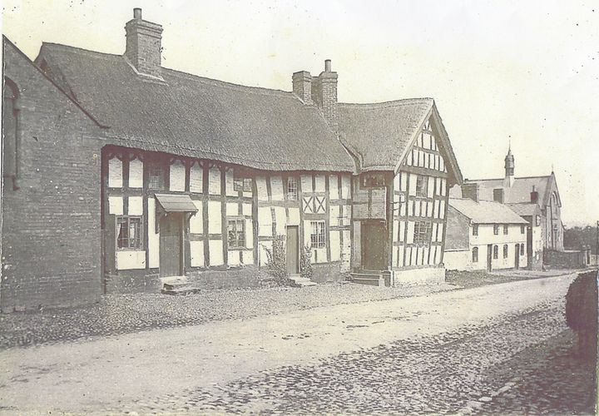

An 1871 Report of Government Sanitary Inspector on the properties on Old Hall Street stated
…the houses in Old Hall Street get rid of their sewage chiefly by gutters into a pool situated barely 50 yards from the rear.
This sewage pool is intended to irrigate the meadow in which it is situate, but this appears to have failed…

A meeting of the Church Wardens was subsequently held in the Vestry room to “take into consideration the amount of dilapidations charged on the houses on Old Hall Street, that are now out of lease through the death of Mr Gardner from America.”

32/ The Village Blacksmith

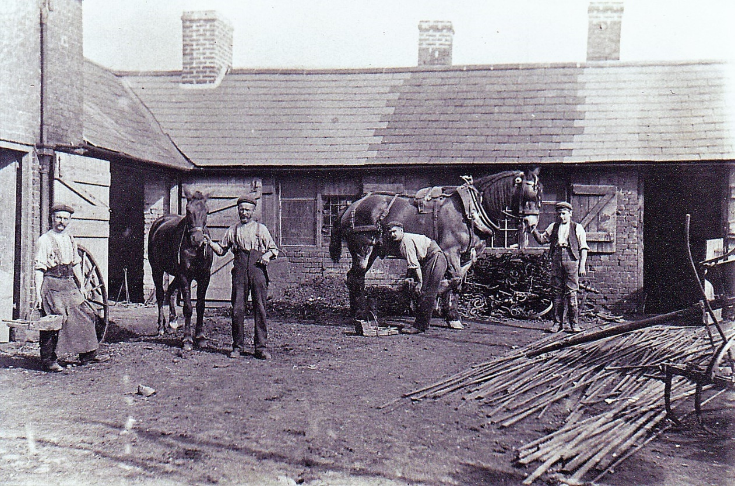

Malpas Online | The Village Blacksmith (malpascheshire.org)

There were two smithies recorded on the 1836 – 1841 Tithe Maps for Malpas.
One was situated on the corner of Well Street and Well Avenue.
The other one was on Cross o' th' Hill Road where the residential dwelling of The Oaks now exists.

A new Smithy was built on Old Hall Street following the demolition of 10 small cottages.
The Smithy was run by Lloyd Furber in the early 1900's and eventually was converted into a service garage with petrol pumps by his son Harold Furber; this to take advantage of the growing Motor trade. Later his two sons Jack and Eric took over the business.

33/ Malpas Garage

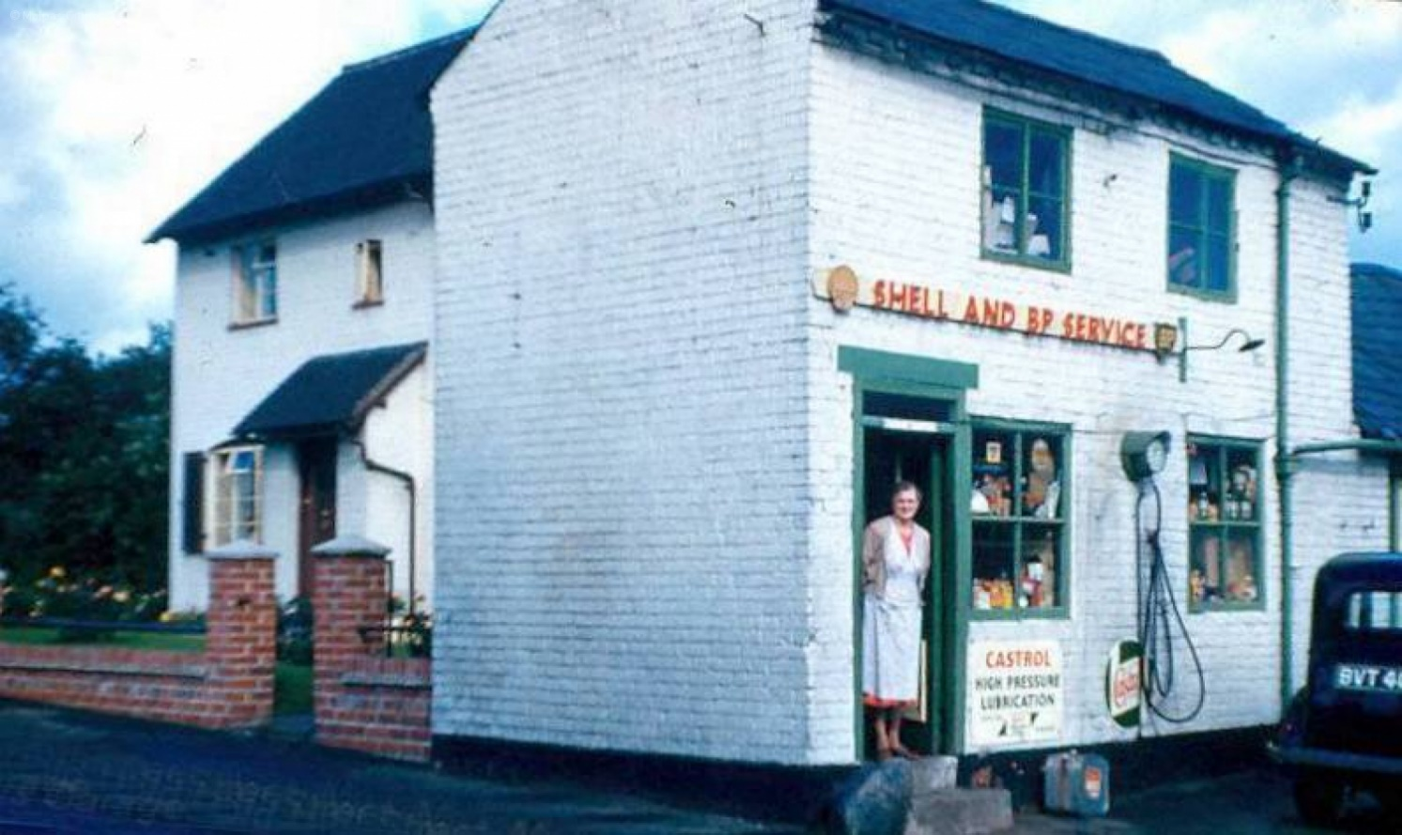

The site on Old Hall Street was previously occupied by Malpas Smithy’s which was run by Lloyd Furber in early 1900.

To take advantage of the growing Motor trade, it was converted by his son Harold Furber into a service garage with petrol pumps
Sometime between 1928 and 1939 the business became known as Smithy Garage (Tel. No. Malpas 65).

The garage closed in the early 21st century and was eventually bought by the Malpas Co-operative Society, which completely cleared the site and built a new store there in early 2021.

34/ The Co-Op Convenience Store

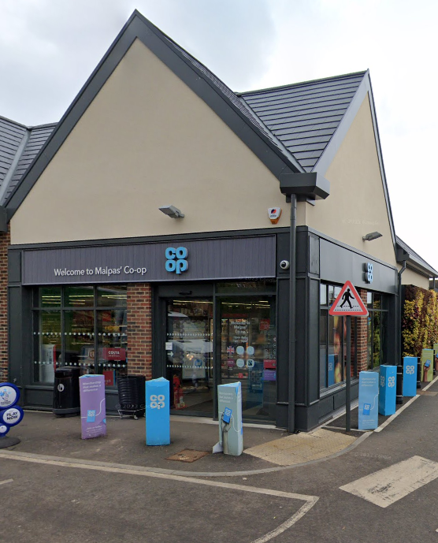

The Malpas Co-operative store now occupies a site on Old Hall Street, which has seen development dating back to the mid-19th century when the site first accommodated seven paupers’ cottages.

Previous usage of the site has also included a smithy and a garage.

In 2021 the disused garage was cleared to make way for the new Co-Op store which was relocated from the High Street to increase the quantity and scope of the products being sought by the increasing local population.

